老式TL494_KA7500半桥ATX电源三极管改进为MOS (发起人：Shadow Ferry)
Improve Old Half-bridge ATX Power Supplies from BJT to MOS (Initiator: Shadow Ferry)

前言：
F.1:生命没有彩排！！！务必确保所有变压器即使在单一介质/热失效时也至少满足加强绝缘！！！F.2:莫要机械模仿！你可能需要按实际情况调节参数，该文也可能存在错误。
F.3:作为业余人士，意在用相似部件微调架构减轻我们共同的地球母亲资源和能源消耗。
F.4:已经大致比较出修改后次级3.3V使用TMBS®或SBR®特殊肖特基的MOS半桥达80 PLUS®银牌等级。
Foreword:
F.1: LIFE IS NOT A REHEARSAL!!! Do make sure that all the transformers are of reinforced insulation at least even if there is a single dielectric/thermal failure!!!
F.2: DO NOT BE A COPYCAT! You may have to adjust the parameters according to your real situation, and also there may be errors in this article.
F.3: As an amateur, the initiator intends to relive the earth, our co-mother, of resource & energy consumption while we are using similar components but tiny different architecture.
F.4: It is roughly compared that the modified MOS half bridge with 3.3V secondary rectification by TMBS® (Trench MOS Barrier Schottky) or SBR® (Super Barrier Rectifier) special Schottkies reaches the 80 PLUS® silver rank.

回合1：改待机RCC电路（注意：RCC的辅助绕组同名端不同于常规反激变压器）
Round 1: Change the standby RCC circuit (Beware that the magnetic polarity of a RCC’s auxilary winding is different from an ordinary flyback transformer)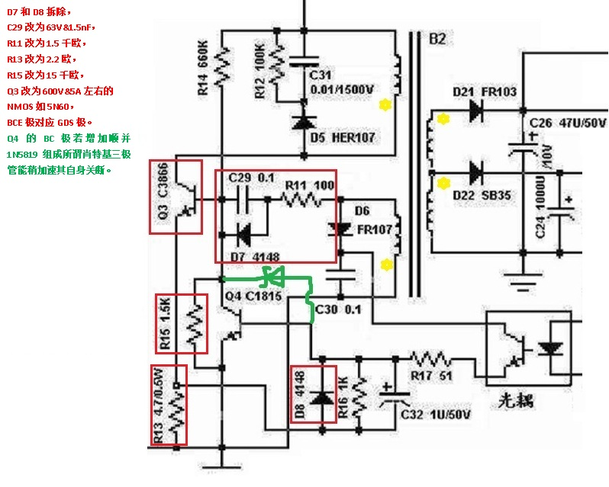
图R1，Figure R1
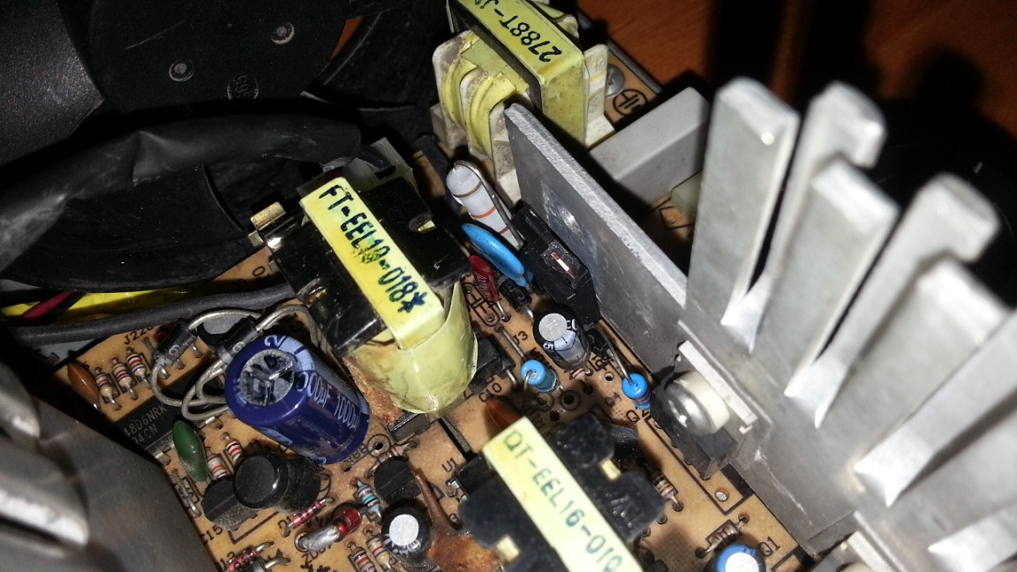
证物R1.1，Evidence R1.1
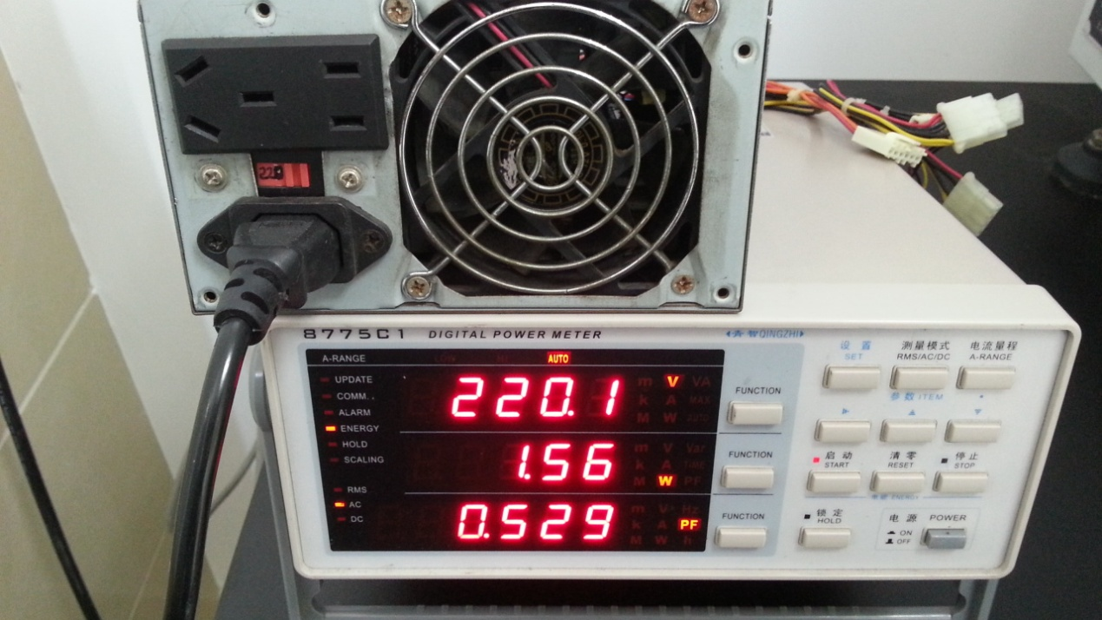
证物R1.2，Evidence R1.2

回合2：改驱动变压器（必须至少加强绝缘且无任何固有式或预留式气隙！！！）
Round 2: Change the driving transformer (MUST be of reinforced insulation at least & no any gap either inherent or deliberate!!!)
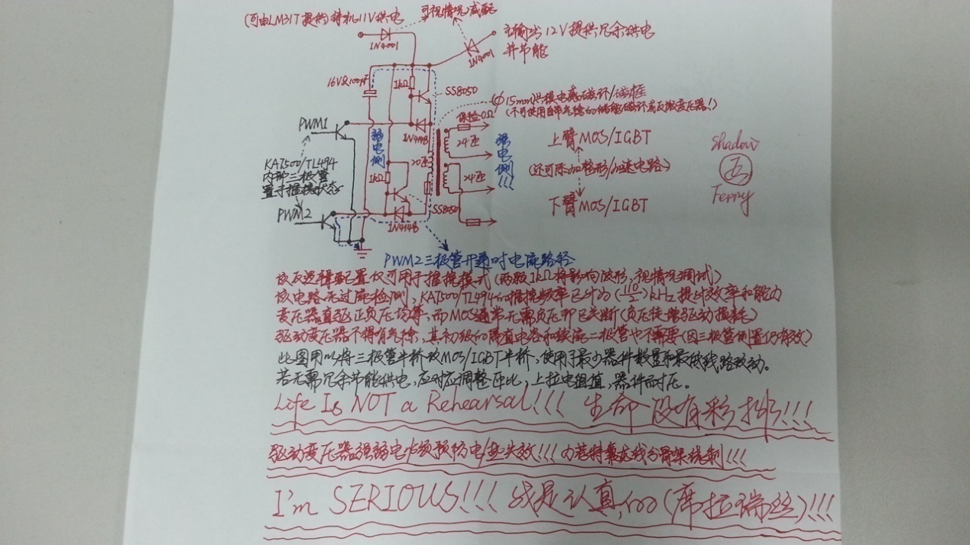
图R2.1，Figure R2.1
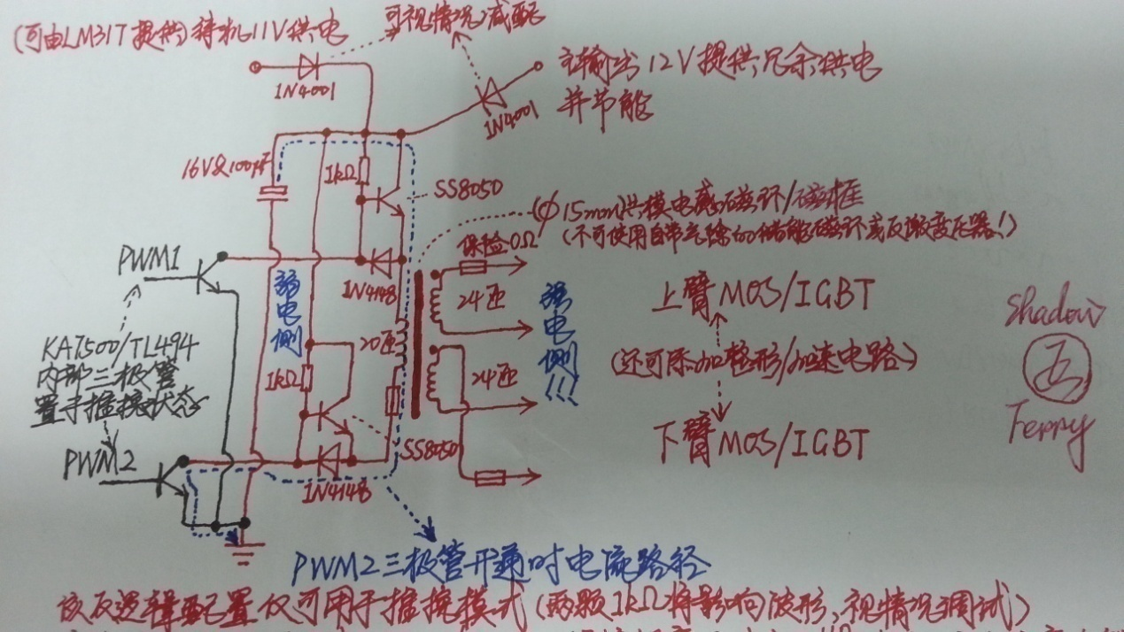
图R2.2，Figure R2.2
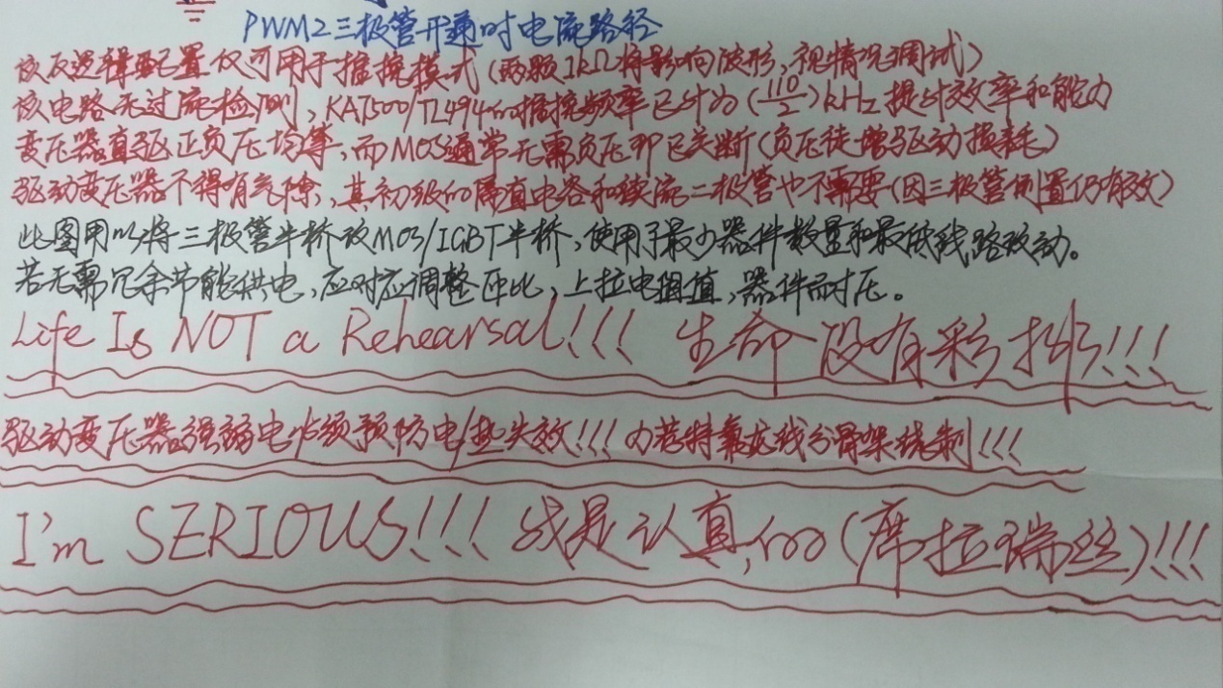
图R2.3，Figure R2.3
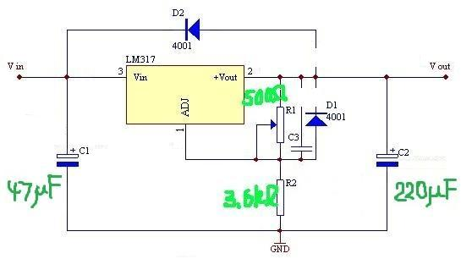
图R2.4，Figure R2.4
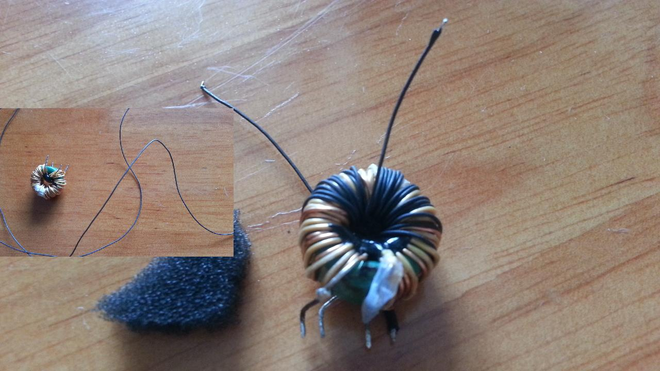
证物R2.1，Evidence R2.1
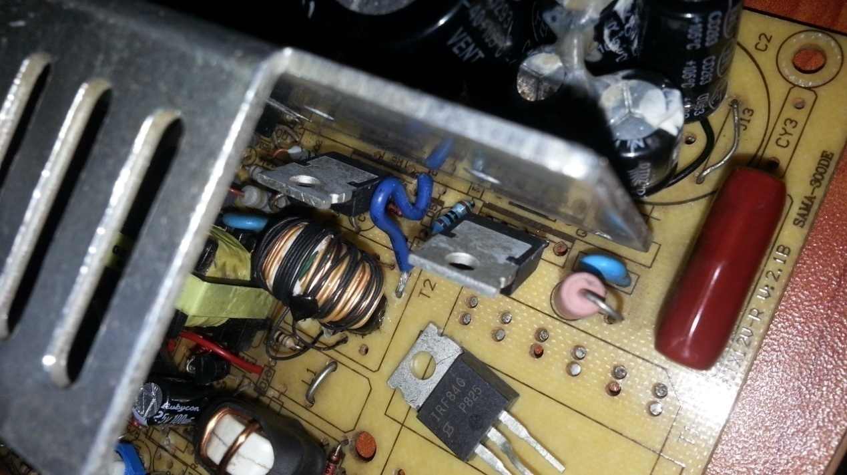
证物R2.2，Evidence R2.2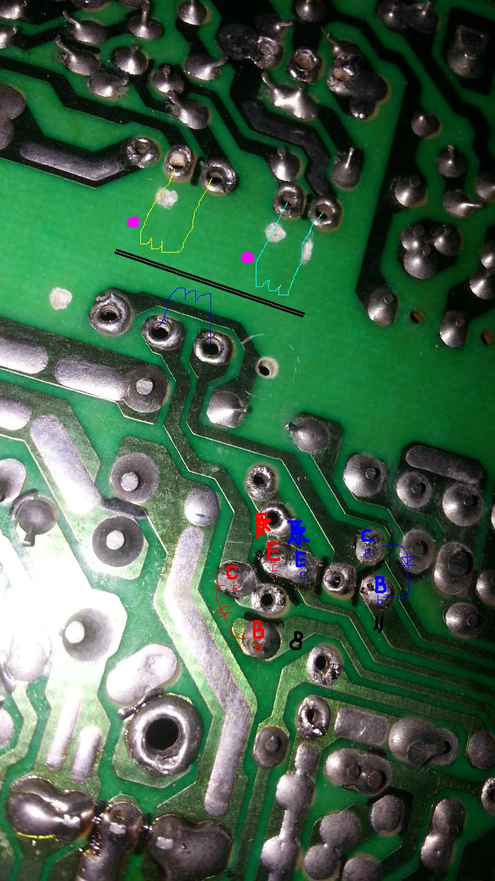
证物R2.3，Evidence R2.3
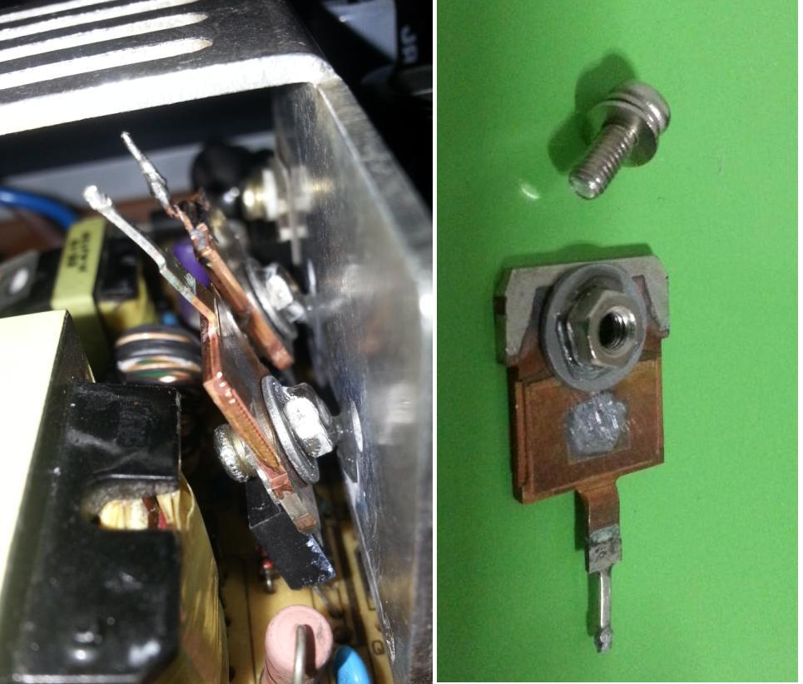
证物R2.4，Evidence R2.4
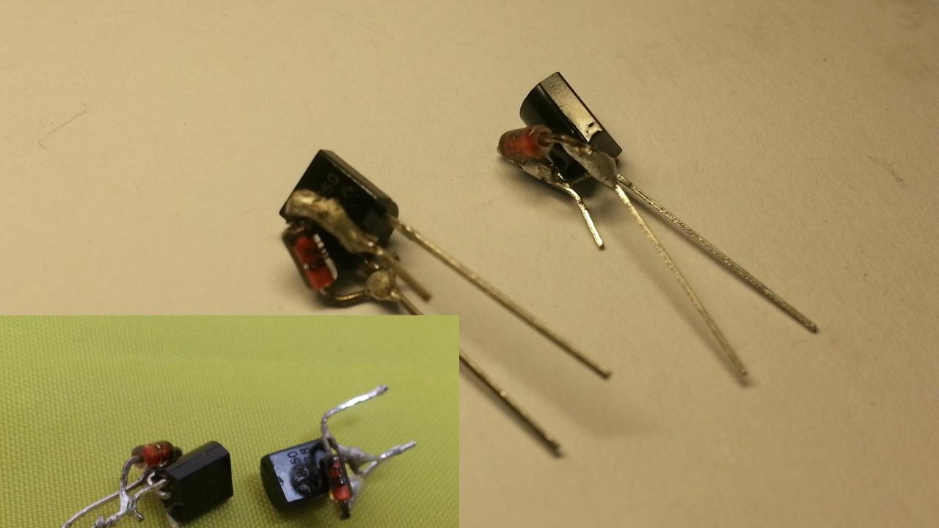
证物R2.5，Evidence R2.5
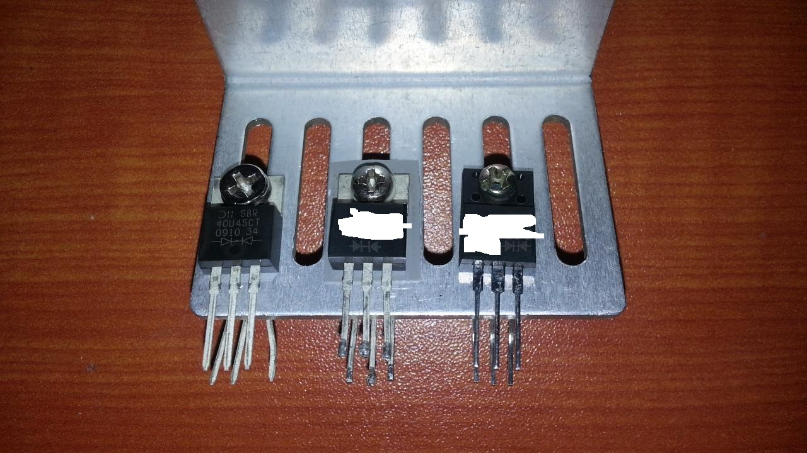
证物R2.6（所有双二极管各自视为/用作单颗更好），
Evidence R2.6 (All dual diodes are better regarded/used as single respectively)
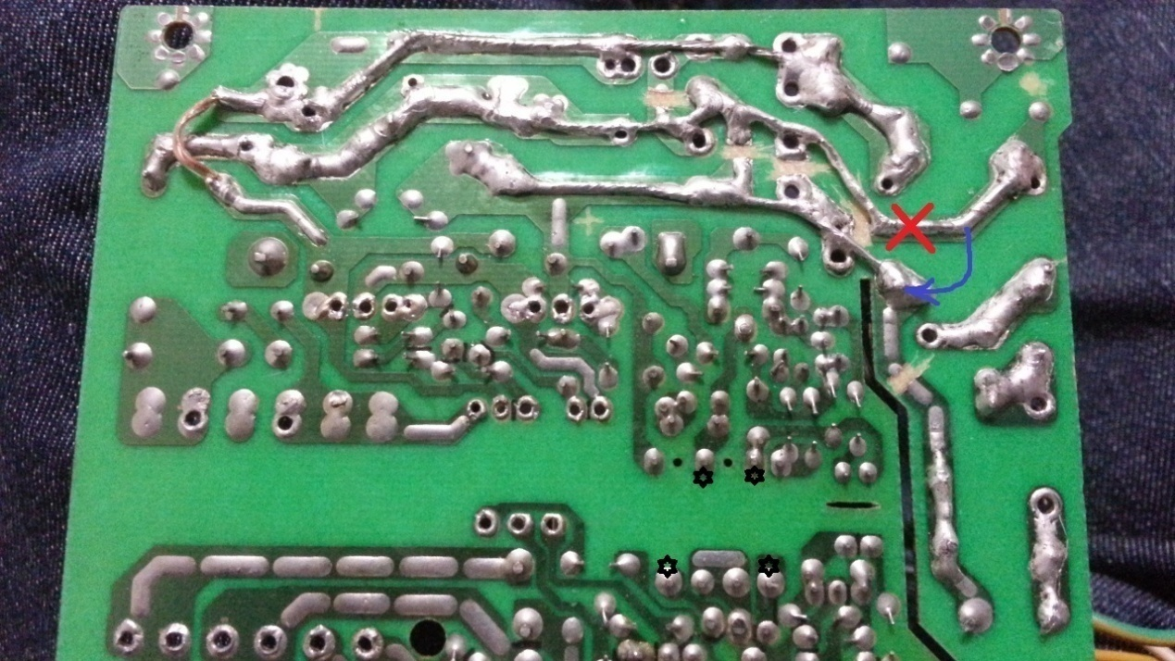
证物R2.7，Evidence R2.7
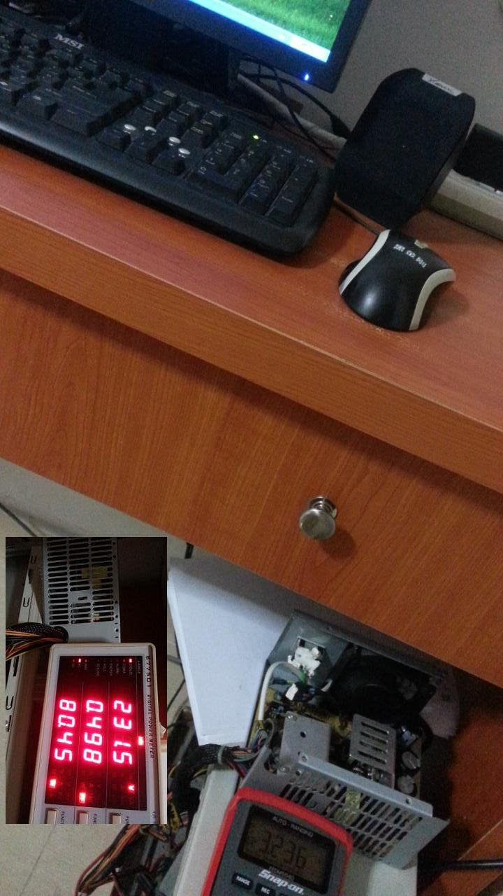
证物R2.8，Evidence R2.8
回合3：重构主变压器（肖特基二极管都用自驱MOS代替。作者失察，8.8V和5V本不该合并整流器！！！应分开整流&降压或使用对称的桥式CMOS加辅助绕组/桥式肖特基&降压，
因为4+4匝在储能电感前约产生32V会击穿MOS的G极！）
Round 3: Reform the main transformer (To replace Schottky diodes by self-driven MOS. It’s the author’s oversight that the rectifiers of 8.8V and 5V SHOULDN’T HAVE been combined!!! Separate them & step down consequently or use symmetric bridge CMOS rectification with auxiliary windings/bridge Schottkies & buck consequently, because the 4+4 turns generate approx. 32V, before the energy storage inductor, which breaks down an MOS’ gate!)
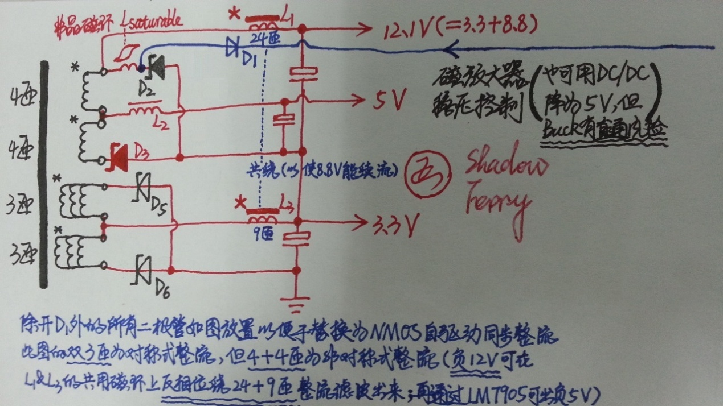
图R3.1（双3匝出3.3V，4+4匝出8.8V），Figure R3.1 (Dual 3 turns for 3.3V, 4+4 turns for 8.8V)
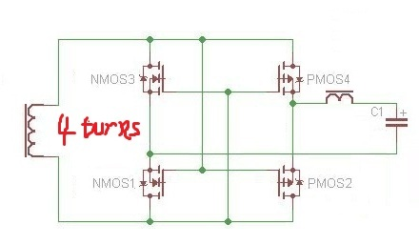
图R3.2（直驱CMOS桥式整流原理图，4匝约产生16V），
Figure R3.2 (Direct-driven CMOS bridge rectification schematic, 4 turns generate approx. 16V)
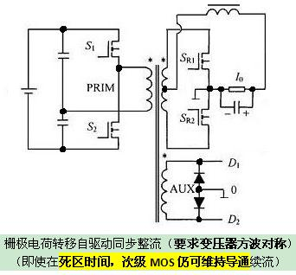
图R3.3（栅极电荷转移自驱动同步整流原理图），
Figure R3.3 (Gate charge transfer self-driven synchronous rectification schematic)
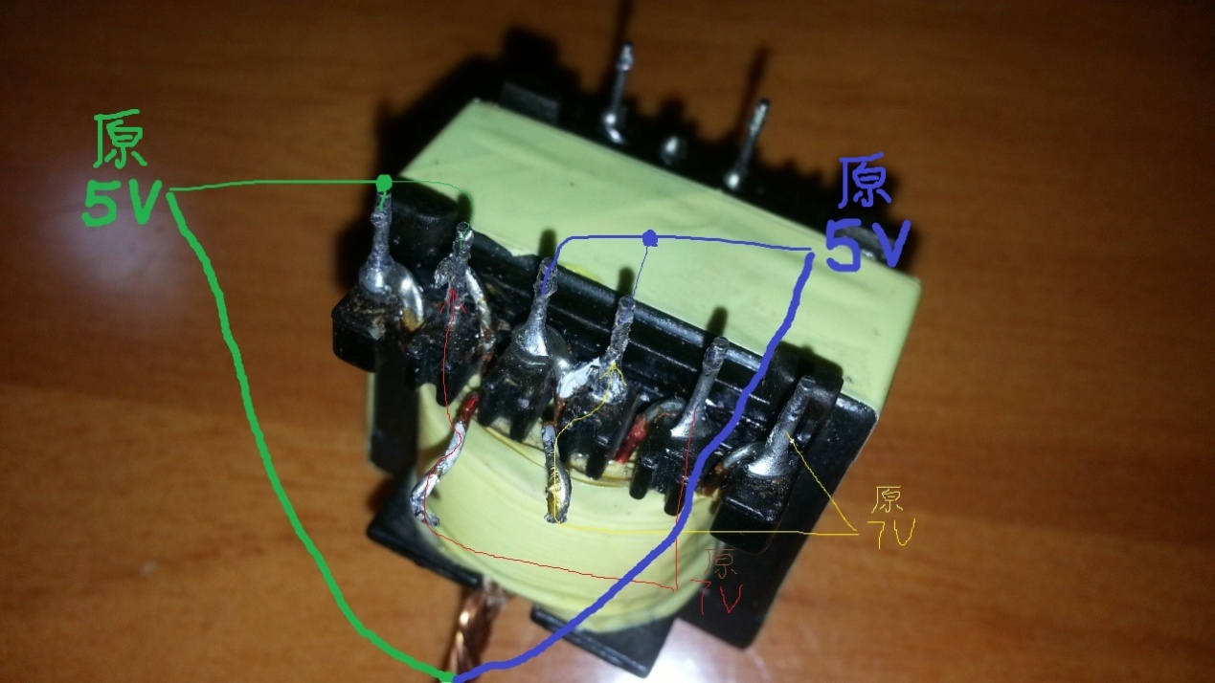
提议R3.1（将原双4匝改为4+4匝），Proposal R3.1 (Reform the original dual 4T to 4+4T)
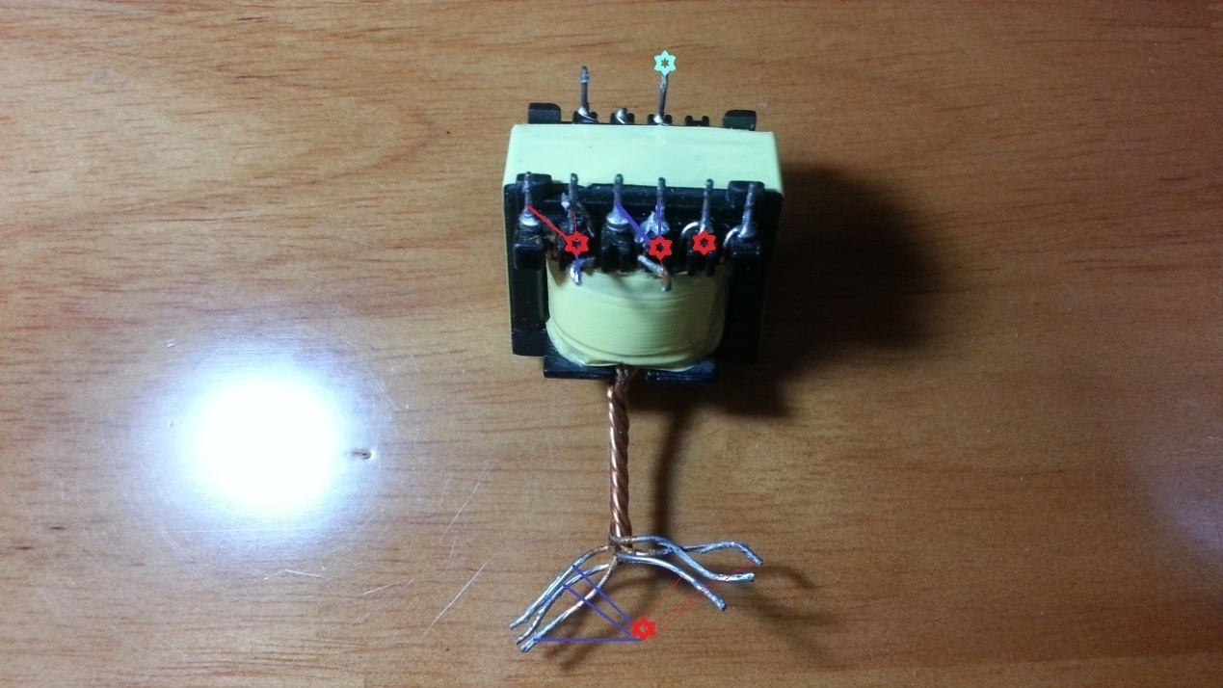
提议R3.2（标记同名端），Proposal R3.2 (Identify the same magnetic polarity terminals)
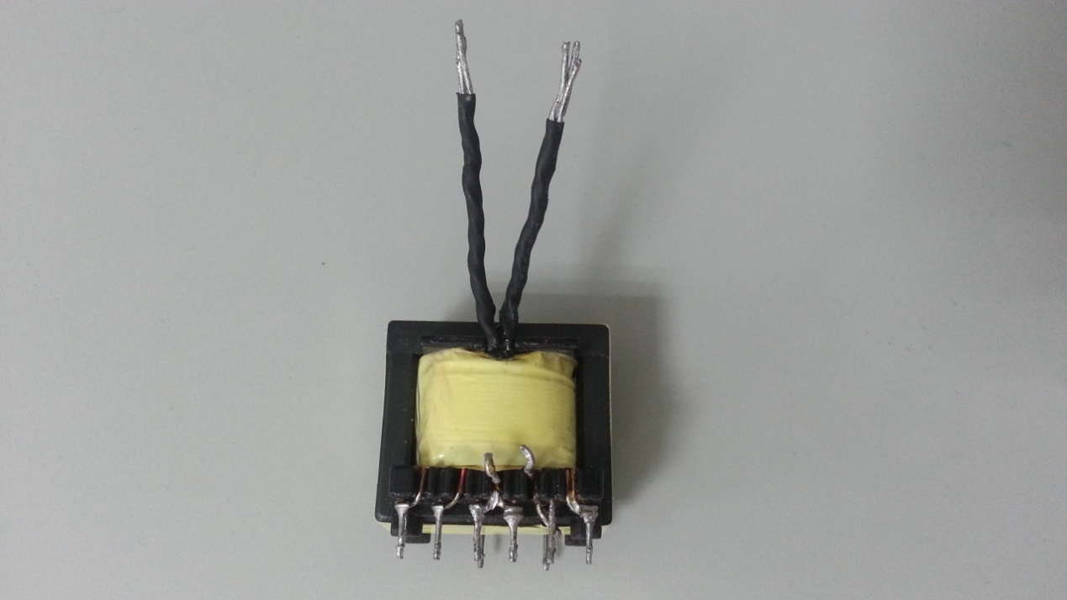
提议R3.3（分离原麻花状公共端，不再用作中抽；此法无需对调PCB正负极。
务必借助万用表确保绕组已正确改动！！！），
Proposal R3.3 (Separate the original twisted common terminal, not as center tap any more;
No need to exchange the positive and negative polarities of PCB, in this way.
MUST ensure all necessary change is done properly by multimeter!!!)
回合4：改半桥前端
Round 4: Change the front end of the half bridge
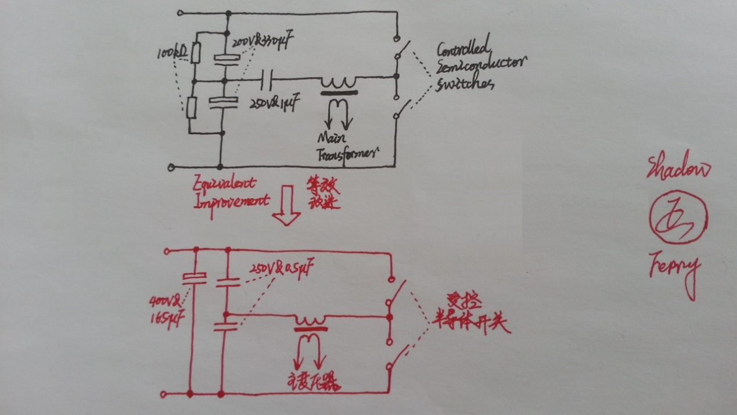图R4，Figure R4

Drop me a brick or drop me a line?
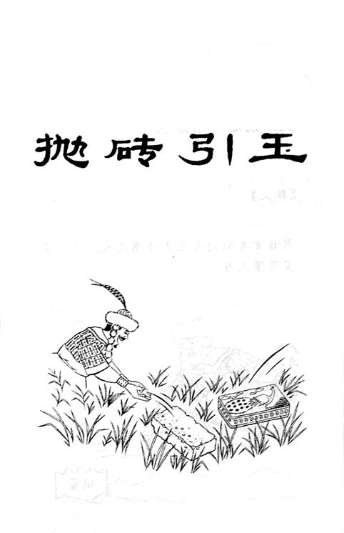

*** End of Document ***

