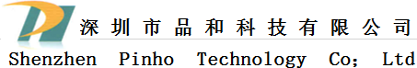 | Product type | SMD power inductors
 | Type | SER0805□□□ MAB
- Product Description
  - 8.40×8.40mm Max. (L×W), 5.5mm Max. height.
  - Standard Type, High Power Type, Ultra Power Type are available.
  - Inductance Range:0.35～7.1μH (Standard type ); 0.5～10.0μH
(Low D.C.R type);0.2uH～4.0μH (High Power type).
  - Saturation Current range: 2.6～12.0A(Low D.C.R type); 3.8～18.4A
(Standard type ) ;7.2～32.0A (High Power type).
  - Temperature rise current 6.5～18.0A.

  - In addition to the standards versions shown here,
custom inductors are also available to meet your exact requirements.
- Feature& Application
  - Mn-Zn core used, Flat wire used.
  - Super high current Inductors, ideally used in portable computer CPU power supply.
  - RoHS Compliance and Halogen free.
- Dimensions (mm)
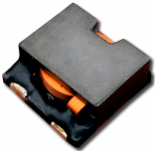
- Pad Layout(mm) ◆ Schematics (Bottom)

- Characteristic description

TAPE | INDUCTORS  (uH) | Test Frequency | DCR  (mΩ) | Saturation Current(A) | Temperature  Rise Current(A) | Test environment
SER0805 | 0.20~10 | 100KHz | 2.50~15 | 32~2.6 | 18.0~6.50 | 20℃
a、Saturation Current: The DC current at which the inductance decreases to 75% of
it's nominal value.
b、Temperature rise current:The DC current at which the temperature rise is
△t＝40℃.(Ta＝20℃)
 | Product type | SMD power inductors
 | Type | SER1030□□□ MAB
- Product Description
  - 10.4×10.4mm Max. (L×W), 4.0mm Max. height.
  - Inductance range: 1.2～3.6uH.
  - Rated current range: 4.4～9.7A.
  - In addition to the reference versions of parameters shown here,
custom designs are available to meet your exact requirements.
- Feature& Application
  - Mn-Zn core used, Flat wire used.
  - Super high current Inductors, ideally used in portable computer CPU power supply.
  - RoHS Compliance and Halogen free.
- Dimensions (mm)
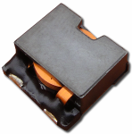
Pad Layout(mm) ◆ Schematics (Bottom)
- Characteristic description

TAPE | INDUCTORS  (uH) | Test Frequency | DCR  (mΩ) | Saturation Current(A) | Temperature  Rise Current(A) | Test environment
SER1030 | 1.20 ~3.60 | 100KHz | 5.9~22.5 | 13.5~7.90 | 9.70~4.40 | 20℃

a、Saturation Current: The DC current at which the inductance decreases to 65% of
it's nominal value.
b、Temperature rise current:The DC current at which the temperature rise is
△t＝40℃.(Ta＝20℃)

 | Product type | SMD power inductors
 | Type | SER1040□□□MAB
- Product Description
  - 10.4×10.4mm Max. (L×W), 4.5mm Max. height.
  - Both standard type and Low DCR type of SER1040 are available.
  - Inductance range: 0.22～2.50uH(SER1040 Standard type);0.36～4.3uH(SER1040 Low D.C.R type ).
  - Saturation Current range: 11.8～39.6A(SER1040 Standard type ) ;7.0～24.2A(SER1040 Low D.C.R type).
  - Temperature rise current 5.0～18.0A.
  - In addition to the standards versions shown here, custom inductors
are also available tomeet your exact requirements
- Feature& Application
  - Mn-Zn core used, Flat wire used.
  - Super high current Inductors, ideally used in portable computer CPU power supply.
  - RoHS Compliance and Halogen free.
- Dimensions (mm)
- Pad Layout(mm) ◆ Schematics (Bottom)
- Characteristic description

TAPE | INDUCTORS  (uH) | Test Frequency | DCR  (mΩ) | Saturation Current(A) | Temperature  Rise Current(A) | Test environment
SER1040 | 0.22 ~4.30 | 100KHz | 2.2~21.8 | 39.6~7.00 | 18.0~5.0 | 20℃
a、Saturation current: The DC current at which the inductance decreases to 65%
(for the inductance tolerance :±30%) or 75% (for the inductance tolerance:±20%)
of its nominal.
b、Temperature rise current:The DC current at which the temperature rise is
△t＝40℃(Ta＝20℃).
 | Product type | SMD power inductors
 | Type | SER1050□□□MAB
- Product Description
  - 10.4×10.4mm Max. (L×W), 5.6mm Max. height.
  - Both standard type and Low DCR type of SER1050 are available.
  - Inductance Range:0.22～5.0uH (standard type );0.36～8.8μH(Low D.C.R type); 0.15～3.0μH (High Power type).
  - Saturation Current range: 8.4～40.0 A(Standard type ) ;4.8～24.0A(Low D.C.R type);12.6～55.0A (High Power type).
  - Temperature rise current 4.9～19.0A.
  - In addition to the standards versions shown here, custom inductors are also available tomeet your exact requirements.
- Feature& Application
  - Mn-Zn core used, Flat wire used.
  - Super high current Inductors, ideally used in portable computer CPU power supply.
  - RoHS Compliance and Halogen free.
- Dimensions (mm)
- Pad Layout(mm) ◆ Schematics (Bottom)
- Characteristic description

TAPE | INDUCTORS  (uH) | Test Frequency | DCR  (mΩ) | Saturation Current(A) | Temperature  Rise Current(A) | Test environment
SER1050 | 0.15 ~8.80 | 100KHz | 1.7~23.8 | 55.0~4.80 | 19.0~4.9 | 20℃
a、Saturation current: The DC current at which the inductance decreases to 65%
(for the inductance tolerance :±30%) or 75% (for the inductance tolerance:±20%)
of its nominal.
b、Temperature rise current:The DC current at which the temperature rise is
△t＝40℃(Ta＝20℃).
 | Product type | SMD power inductors
 | Type | SER1204□□□MAB
- Product Description
  - 12.9×12.9mm Max. (L×W), 5.0mm Max. height
  - Standard Type, High Power Type, Ultra Power Type are available.
  - Inductance Range: 0.68～4.0μH (standard type );0.35～2.2μH (High Power type).
  - Saturation Current range: 8.8～20.8 A (Standard type ) ;16.2～38.4A
(High Power type).
  - Temperature rise current range 12.6～18.4A.
  - In addition to the standards versions shown here, custom inductors
are also available tomeet your exact requirements.
- Feature& Application
  - Mn-Zn core used, Flat wire used.
  - Super high current Inductors, ideally used in portable computer CPU power supply.
  - RoHS Compliance and Halogen free.
- Dimensions (mm)
- Pad Layout(mm) ◆ Schematics (Bottom)
- Characteristic description

TAPE | INDUCTORS  (uH) | Test Frequency | DCR  (mΩ) | Saturation Current(A) | Temperature  Rise Current(A) | Test environment
SER1204 | 0.35~4.00 | 100KHz | 1.6~7.6 | 38.4~8.0 | 18.4~12.6 | 20℃
a、Saturation Current: The DC current at which the inductance decreases to 75% of
it's nominal value.
b、Temperature rise current:The DC current at which the temperature rise is
△t＝40℃.(Ta＝20℃)
 | Product type | SMD power inductors
 | Type | SER1205□□□MAB
- Product Description
  - 12.9×12.9mm Max. (L×W), 5.6mm Max. height
  - Standard Type, High Power Type, Ultra Power Type are available
  - Inductance range : 0.68～10μH(Standard type );0.47～7.2μH(High Power type); 0.35～5.6μH (Ultra Power Type).
  - Saturation current range: 5.0～20.4A(Standard type ) ;
7.8～28.8A (High Power type); 9.5～35.0A (Ultra Power Type).
  - Temperature rise current range 7.6～19.5A.
  - In addition to the standards versions shown here, custom inductors
are also available tomeet your exact requirements.
- Feature& Application
  - Mn-Zn core used, Flat wire used.
  - Super high current Inductors, ideally used in portable computer CPU power supply.
  - RoHS Compliance and Halogen free.
- Dimensions (mm)
- Pad Layout(mm) ◆ Schematics (Bottom)
- Characteristic description

TAPE | INDUCTORS  (uH) | Test Frequency | DCR  (mΩ) | Saturation Current(A) | Temperature  Rise Current(A) | Test environment
SER1205 | 0.35~10 | 100KHz | 1.5~13.5 | 35~5 | 19.5~7.6 | 20℃
a、 Saturation current: The DC current at which the inductance decreases to 65%
(for the inductance tolerance :±30%) or 75% (for the inductance tolerance:±20%)
of its nominal.
b、Temperature rise current:The DC current at which the temperature rise is
△t＝40℃(Ta＝20℃).
 | Product type | SMD power inductors
 | Type | SER1405□□□MAB
- Product Description
  - 14.9×14.9mm Max. (L×W), 6.0mm Max. height
  - Standard Type, High Power Type, Ultra Power Type are available.
  - Inductance range : 0.68～6.1μH(Standard type );
0.56～5.0μH (High Power type).
  - Saturation Current range: 10.4～30.0A(Standard type ) ;
13.1～36.0A (High Power type).
  - Temperature rise current range 9.5～23.0A.
  - In addition to the standards versions shown here, custom inductors
are also available tomeet your exact requirements.
- Feature& Application
  - Mn-Zn core used, Flat wire used.
  - Super high current Inductors, ideally used in portable computer CPU power supply.
  - Qualification to AEC-Q200
  - RoHS Compliance and Halogen free.
- Dimensions (mm)
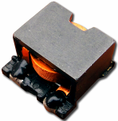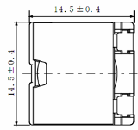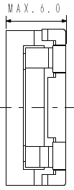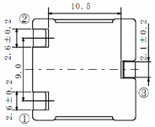
- Pad Layout(mm) ◆ Schematics (Bottom)
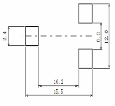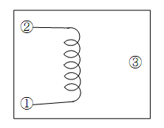
- Characteristic description

TAPE | INDUCTORS  (uH) | Test Frequency | DCR  (mΩ) | Saturation Current(A) | Temperature  Rise Current(A) | Test environment
SER1405 | 0.56~6.10 | 100KHz | 1.70~10.8 | 36~10.4 | 23~9.5 | 20℃
a、Saturation Current: The DC current at which the inductance decreases to 75% of
it's nominal value.
b、Temperature rise current:The DC current at which the temperature rise is
△t＝40℃.(Ta＝20℃)
 | Product type | SMD power inductors
 | Type | SER1407□□□MAB
- Product Description
  - 14.9×14.9mm Max. (L×W), 8.0mm Max. height
  - Standard Type, High Power Type, Ultra Power Type are available.
  - Inductance range: 0.5～12μH(Low D.C.R type); 0.4～9.5μH (standard type );
0.3～7.3μH(High Power type).
  - Saturation Current range: 8.0～39.6A(Low D.C.R type); 11.2～52.8A
(Standard type ) ;14.6～70A (High Power type).
  - Temperature rise current range 8.5～23.0A.
  - In addition to the standards versions shown here, custom inductors
are also available tomeet your exact requirements.
- Feature& Application
  - Mn-Zn core used, Flat wire used.
  - Super high current Inductors, ideally used in portable computer CPU power supply.
  - RoHS Compliance and Halogen free.
- Dimensions (mm)
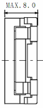
- Pad Layout(mm) ◆ Schematics (Bottom)
- Characteristic description

TAPE | INDUCTORS  (uH) | Test Frequency | DCR  (mΩ) | Saturation Current(A) | Temperature  Rise Current(A) | Test environment
SER1407 | 0.30~12 | 100KHz | 1.18~13.3 | 70~8.0 | 23~8.5 | 20℃
a、Saturation Current: The DC current at which the inductance decreases to 75% of
it's nominal value.
b、Temperature rise current:The DC current at which the temperature rise is
△t＝40℃.(Ta＝20℃)

 | Product type | SMD power inductors
 | Type | SER1810□□□MAB
- Product Description
  - 22.4×19.2mm Max. (L×W), 11.0mm Max. height
  - Standard Type, High Power Type, Ultra Power Type are available.
  - Inductance Range : 5.6～33uH.
  - Saturation Current range: 5.5～12.0A .
  - Temperature rise current range 12.0～22.5A.
  - In addition to the standards versions shown here, custom inductors
are also available tomeet your exact requirements.
- Feature& Application
  - Mn-Zn core used, Flat wire used.
  - Ideally used in PC and Game machine power supply
  - Operating temperature range: -40℃～+105℃(Including coil’s self temperature rise).
  - RoHS Compliance and Halogen free.
- Dimensions (mm)
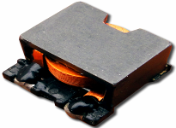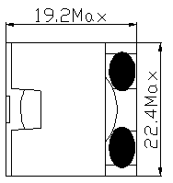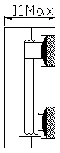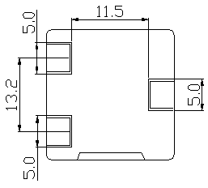
- Pad Layout(mm) ◆ Schematics (Bottom)
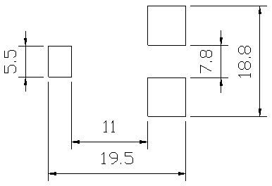
- Characteristic description

TAPE | INDUCTORS  (uH) | Test Frequency | DCR  (mΩ) | Saturation Current(A) | Temperature  Rise Current(A) | Test environment
SER1810 | 2.2~33 | 100KHz | 1.50~9.0 | 15~5.5 | 22.5~12.0 | 20℃
a、Saturation Current: The DC current at which the inductance decreases to 75% of
it's nominal value.
b、Temperature rise current:The DC current at which the temperature rise is
△t＝40℃.(Ta＝20℃)

 | Product type | SMD power inductors
 | Type | SER2009□□□MAB
- Product Description
  - 21.0×14.0mm Max. (L×W), 9.50mm Max. height
  - Standard Type, High Power Type, Ultra Power Type are available.
  - Inductance Range : 2.2～68uH.
  - Saturation Current range: 10～38.0A .
  - Temperature rise current range 8.0～30.0A.
  - In addition to the standards versions shown here, custom inductors
are also available tomeet your exact requirements.
- Feature& Application
  - Mn-Zn core used, Flat wire used.
  - Ideally used in Power module DC-DC Converter
  - RoHS Compliance and Halogen free.
- Dimensions (mm)
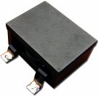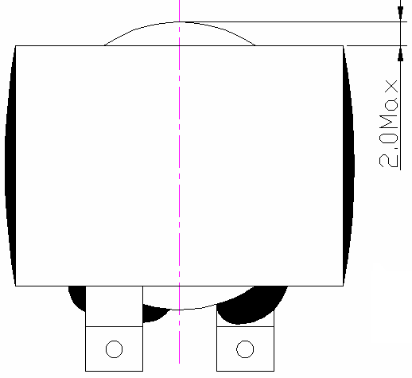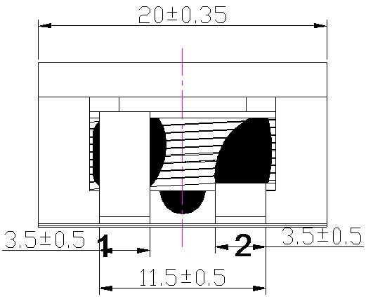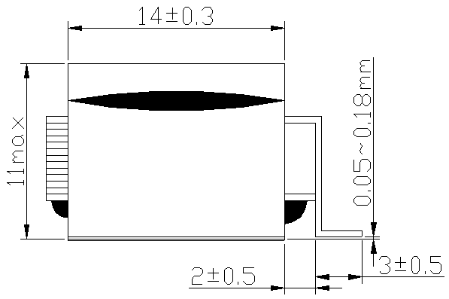
- Pad Layout(mm) ◆ Schematics (Bottom)
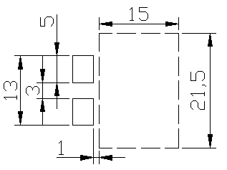
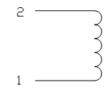
- Characteristic description

TAPE | INDUCTORS  (uH) | Test Frequency | DCR  (mΩ) | Saturation Current(A) | Temperature  Rise Current(A) | Test environment
SER2009 | 2.2~68 | 100KHz | 1.00~20.0 | 38~10 | 8~30.0 | 20℃
a、Saturation Current: The DC current at which the inductance decreases to 80% of
it's nominal value.
b、Temperature rise current:The DC current at which the temperature rise is
△t＝40℃.(Ta＝20℃)

 | Product type | SMD power inductors
 | Type | SER2209□□□MAB
- Product Description
  - 23.5×15.0mm Max. (L×W), 9.50mm Max. height
  - Standard Type, High Power Type, Ultra Power Type are available.
  - Inductance Range :1.0～100uH.
  - Saturation Current range: 12～45.0A .
  - Temperature rise current range 10～38.0A.
  - In addition to the standards versions shown here, custom inductors
are also available tomeet your exact requirements.
- Feature& Application
  - Mn-Zn core used, Flat wire used.
  - Ideally used in Power module DC-DC Converter
  - RoHS Compliance and Halogen free.
- Dimensions (mm)
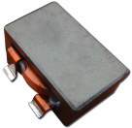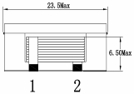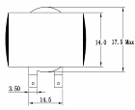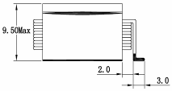
- Pad Layout(mm) ◆ Schematics (Bottom)
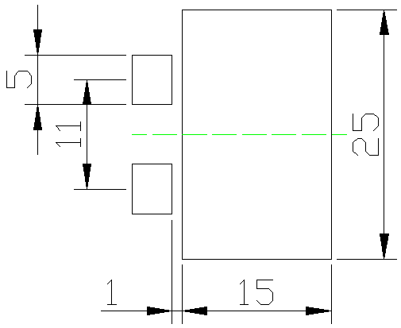
- Characteristic description

TAPE | INDUCTORS  (uH) | Test Frequency | DCR  (mΩ) | Saturation Current(A) | Temperature  Rise Current(A) | Test environment
SER2209 | 1.0~100 | 100KHz | 1.00~30.0 | 45.0~12.0 | 38.0~10 | 20℃
a、Saturation Current: The DC current at which the inductance decreases to 90% of
it's nominal value.
b、Temperature rise current:The DC current at which the temperature rise is
△t＝40℃.(Ta＝20℃)

 | Product type | SMD power inductors
 | Type | SER2509□□□MAB
- Product Description
  - 25.8×19.50mm Max. (L×W), 9.50mm Max. height
  - Standard Type, High Power Type, Ultra Power Type are available.
  - Inductance Range :1.0～68uH.
  - Saturation Current range: 20.0～45.0A .
  - Temperature rise current range 15～40.0A.
  - In addition to the standards versions shown here, custom inductors
are also available tomeet your exact requirements.
- Feature& Application
  - Mn-Zn core used, Flat wire used.
  - Ideally used in Power module DC-DC Converter
  - RoHS Compliance and Halogen free.
- Dimensions (mm)
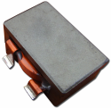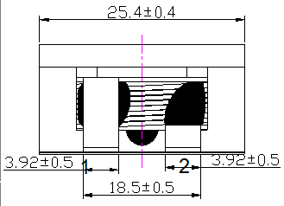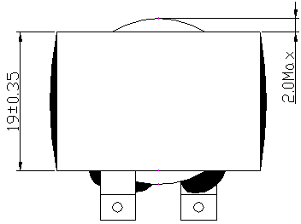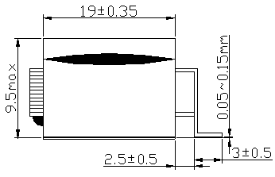
- Pad Layout(mm) ◆ Schematics (Bottom)
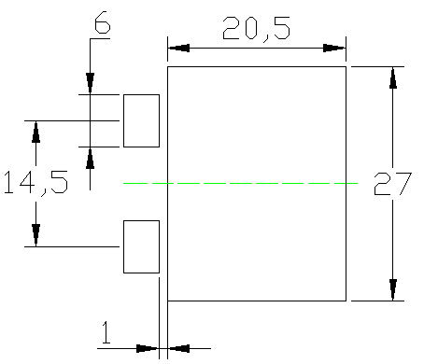
- Characteristic description

TAPE | INDUCTORS  (uH) | Test Frequency | DCR  (mΩ) | Saturation Current(A) | Temperature  Rise Current(A) | Test environment
SER2509 | 1.0~68 | 100KHz | 1.00~28.0 | 45.0~20 | 40.0~15.0 | 20℃
a、Saturation Current: The DC current at which the inductance decreases to 90% of
it's nominal value.
b、Temperature rise current:The DC current at which the temperature rise is
△t＝40℃.(Ta＝20℃)

 | Product type | SMD power inductors
 | Type | SER3009□□□MAB
- Product Description
  - 31.0×21.0mm Max. (L×W), 10.5mm Max. height
  - Standard Type, High Power Type, Ultra Power Type are available.
  - Inductance Range :1.0～68uH.
  - Saturation Current range: 20.0～50A .
  - Temperature rise current range 18～45.0A.
  - In addition to the standards versions shown here, custom inductors
are also available tomeet your exact requirements.
- Feature& Application
  - Mn-Zn core used, Flat wire used.
  - Ideally used in Power module DC-DC Converter
  - RoHS Compliance and Halogen free.
- Dimensions (mm)
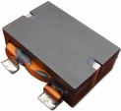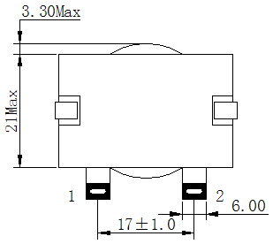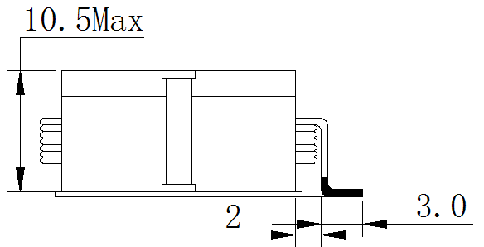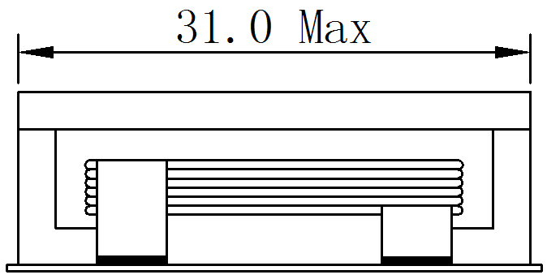
- Pad Layout(mm) ◆ Schematics (Bottom)
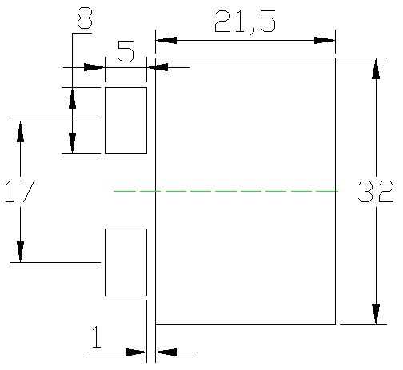
- Characteristic description

TAPE | INDUCTORS  (uH) | Test Frequency | DCR  (mΩ) | Saturation Current(A) | Temperature  Rise Current(A) | Test environment
SER3009 | 1.0~68 | 100KHz | 1.00~25.0 | 50.0~20 | 45.0~18.0 | 20℃
a、Saturation Current: The DC current at which the inductance decreases to 90% of
it's nominal value.
b、Temperature rise current:The DC current at which the temperature rise is
△t＝40℃.(Ta＝20℃)

 | Product type | SMD power inductors
 | Type | SPQ2009□□□MAB
- Product Description
  - 21.0×15.0mm Max. (L×W), 10.0mm Max. height
  - Standard Type, High Power Type, Ultra Power Type are available.
  - Inductance Range :1.0～100uH.
  - Saturation Current range: 15.0～50A .
  - Temperature rise current range 12～45.0A.
  - In addition to the standards versions shown here, custom inductors
are also available tomeet your exact requirements.
- Feature& Application
  - Mn-Zn core used, Flat wire used.
  - Ideally used in Power module DC-DC Converter
  - RoHS Compliance and Halogen free.
- Dimensions (mm)
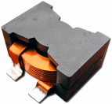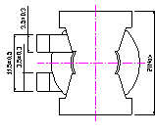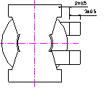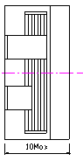
- Pad Layout(mm) ◆ Schematics (Bottom)
- Characteristic description

TAPE | INDUCTORS  (uH) | Test Frequency | DCR  (mΩ) | Saturation Current(A) | Temperature  Rise Current(A) | Test environment
SPQ2009 | 1.0~100 | 100KHz | 2.00~26.8 | 50.0~15 | 45.0~12.0 | 20℃
a、Saturation Current: The DC current at which the inductance decreases to 90% of
it's nominal value.
b、Temperature rise current:The DC current at which the temperature rise is
△t＝40℃.(Ta＝20℃)

 | Product type | power inductors
 | Type | HPE0909100 MAB
- Product Description
  - 9.50×7.50mm Max. (L×W), 10.0mm Max. height
  - Standard Type, High Power Type, Ultra Power Type are available.
  - Inductance:10uH.
  - Saturation Current: 6A .
  - Temperature ascending current: 4.70A.
  - In addition to the standards versions shown here, custom inductors
are also available tomeet your exact requirements.
- Feature& Application
  - Digital Amplifier Inductor/The Flat Wire Use Ferrite Core Type.
  - By using the flat wire, Power inductors can be usrd for large
current with low profile and low resistance.
  - Good shielding, low radiation interference and high fidelity sound effects.
  - Frequency Range: 1MHz
  - RoHS Compliance and Halogen free.
- Dimensions (mm)
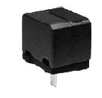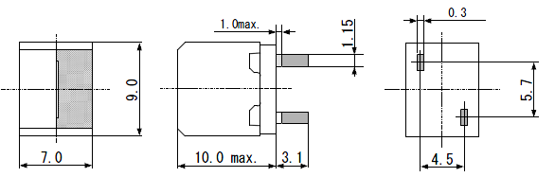
- Pad Layout(mm) ◆ Schematics (Bottom)
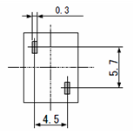
- Characteristic description

TAPE | INDUCTORS  (uH) | Test Frequency | DCR  (mΩ) | Saturation Current(A) | Temperature  Rise Current(A) | Test environment
HPE0909 | 10 | 1KHz | 18 Max | 6.0 | 4.70 | 20℃
a、Saturation Current: The DC current at which the inductance decreases to 75% of
it's nominal value.
b、Temperature rise current:The DC current at which the temperature rise is
△t＝40℃.(Ta＝20℃)
 | Product type | power inductors
 | Type | HPE1315□□□MAB
- Product Description
  - 13.5×8.50mm Max. (L×W), 15.0mm Max. height
  - Standard Type, High Power Type, Ultra Power Type are available.
  - Inductance:10uH、15uH、22uH、27uH、33uH.
  - Saturation Current range: 3.40～6.0A .
  - Temperature rise current range:5.3～8.0A.
  - In addition to the standards versions shown here, custom inductors
are also available tomeet your exact requirements.
- Feature& Application
  - Digital Amplifier Inductor/The Flat Wire Use Ferrite Core Type.
  - By using the flat wire, Power inductors can be usrd for large
current with low profile and low resistance.
  - Good shielding, low radiation interference and high fidelity sound effects.
  - Frequency Range: 1MHz
  - RoHS Compliance and Halogen free.
- Dimensions (mm)
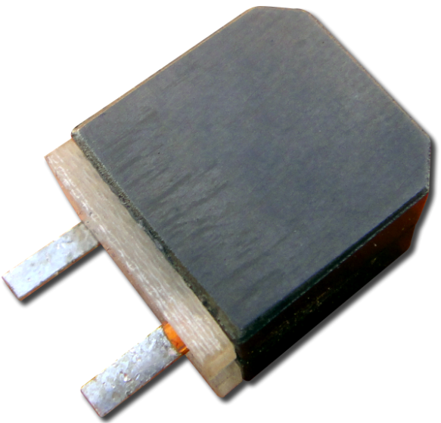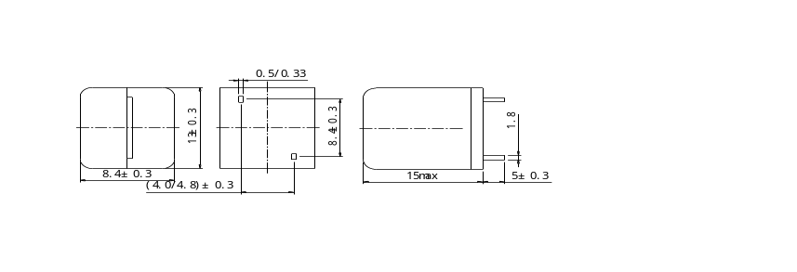
- Pad Layout(mm) ◆ Schematics (Bottom)
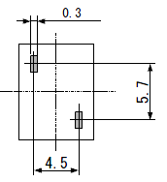
- Characteristic description

TAPE | INDUCTORS  (uH) | Test Frequency | DCR  (mΩ) | Saturation Current(A) | Temperature  Rise Current(A) | Test environment
HPE1315 | 10~33 | 1KHz | 5.4~14.7 | 6~3.4 | 5~5.3 | 20℃
a、Saturation Current: The DC current at which the inductance decreases to 75% of
it's nominal value.
b、Temperature rise current:The DC current at which the temperature rise is
△t＝40℃.(Ta＝20℃)

 | Product type | power inductors
 | Type | HPE1315100MBB
- Product Description
  - 13.5×6.50mm Max. (L×W), 15.0mm Max. height
  - Standard Type, High Power Type, Ultra Power Type are available.
  - Inductance:10uH.
  - Saturation Current: 9.0A .
  - Temperature ascending current: 6.0A.
  - In addition to the standards versions shown here, custom inductors
are also available tomeet your exact requirements.
- Feature& Application
  - Digital Amplifier Inductor/The Flat Wire Use Ferrite Core Type.
  - By using the flat wire, Power inductors can be usrd for large
current with low profile and low resistance.
  - Good shielding, low radiation interference and high fidelity sound effects.
  - Frequency Range: 1MHz
  - RoHS Compliance and Halogen free.
- Dimensions (mm)
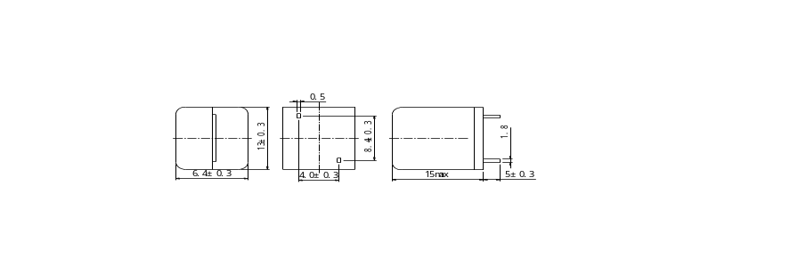
- Pad Layout(mm) ◆ Schematics (Bottom)
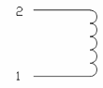
- Characteristic description

TAPE | INDUCTORS  (uH) | Test Frequency | DCR  (mΩ) | Saturation Current(A) | Temperature  Rise Current(A) | Test environment
HPE1315 | 10 | 1KHz | 8.8 Max | 9.0 | 6.0 | 20℃
a、Saturation Current: The DC current at which the inductance decreases to 75% of
it's nominal value.
b、Temperature rise current:The DC current at which the temperature rise is
△t＝40℃.(Ta＝20℃)
 | Product type | power inductors
 | Type | HPE1415□□□MAB
- Product Description
  - 14.5×9.60mm Max. (L×W), 16.0mm Max. height
  - Standard Type, High Power Type, Ultra Power Type are available.
  - Inductance: 10uH、15 uH（W=4.4mm）、22uH（W=5.3mm）、27uH、33uH（W=4.4mm）.
  - Saturation Current range: 3.40～6.0A .
  - Temperature rise current range:5.3～8.0A.
  - In addition to the standards versions shown here, custom inductors
are also available tomeet your exact requirements.
- Feature& Application
  - Digital Amplifier Inductor/The Flat Wire Use Ferrite Core Type.
  - By using the flat wire, Power inductors can be usrd for large
current with low profile and low resistance.
  - Good shielding, low radiation interference and high fidelity sound effects.
  - Frequency Range: 1MHz
  - RoHS Compliance and Halogen free.
- Dimensions (mm)
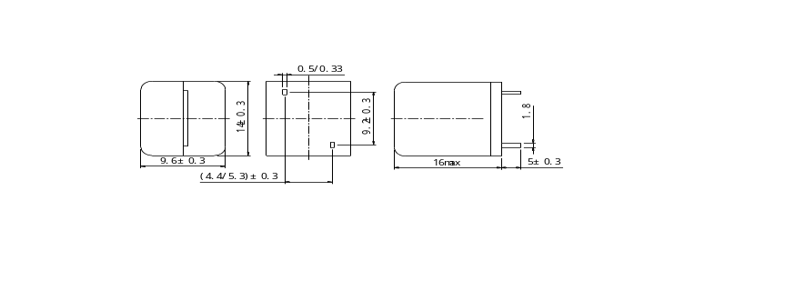
w
- Pad Layout(mm) ◆ Schematics (Bottom)
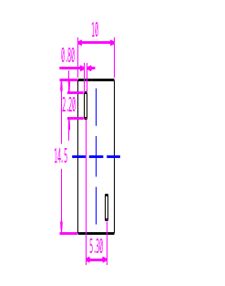
- Characteristic description
TAPE | INDUCTORS  (uH) | Test Frequency | DCR  (mΩ) | Saturation Current(A) | Temperature  Rise Current(A) | Test environment
HPE1415 | 10~33 | 1KHz | 5.9~17.5 | 8.3~6.1 | 7.8~5.1 | 20℃
a、Saturation Current: The DC current at which the inductance decreases to 75% of
it's nominal value.
b、Temperature rise current:The DC current at which the temperature rise is
△t＝40℃.(Ta＝20℃)
 | Product type | power inductors
 | Type | HPE1415100MBB
- Product Description
  - 14.5×7.60mm Max. (L×W), 16.0mm Max. height
  - Standard Type, High Power Type, Ultra Power Type are available.
  - Inductance:10uH.
  - Saturation Current range: 13.5A .
  - Temperature rise current range:6.2A.
  - In addition to the standards versions shown here, custom inductors
are also available tomeet your exact requirements.
- Feature& Application
  - Digital Amplifier Inductor/The Flat Wire Use Ferrite Core Type.
  - By using the flat wire, Power inductors can be usrd for large
current with low profile and low resistance.
  - Good shielding, low radiation interference and high fidelity sound effects.
  - Frequency Range: 1MHz
  - RoHS Compliance and Halogen free.
- Dimensions (mm)
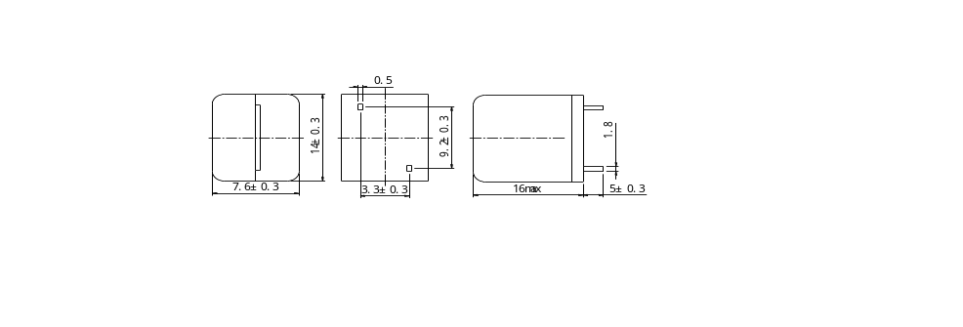
- Pad Layout(mm) ◆ Schematics (Bottom)
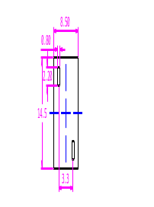
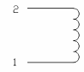
- Characteristic description
TAPE | INDUCTORS  (uH) | Test Frequency | DCR  (mΩ) | Saturation Current(A) | Temperature  Rise Current(A) | Test environment
HPE1415 | 10 | 1KHz | 12.3 | 13.5 | 6.20 | 20℃
a、Saturation Current: The DC current at which the inductance decreases to 75% of
it's nominal value.
b、Temperature rise current:The DC current at which the temperature rise is
△t＝40℃.(Ta＝20℃)
 | Product type | power inductors
 | Type | HPE1718□□□MAB
- Product Description
  - 18.0×15.5mm Max. (L×W), 19.3mm Max. height
  - Standard Type, High Power Type, Ultra Power Type are available.
  - Inductance:10uH、22uH、33uH.
  - Saturation Current range: 7.5~26A .
  - Temperature rise current range:8.2A.
  - In addition to the standards versions shown here, custom inductors
are also available tomeet your exact requirements.
- Feature& Application
  - Digital Amplifier Inductor/The Flat Wire Use Ferrite Core Type.
  - By using the flat wire, Power inductors can be usrd for large
current with low profile and low resistance.
  - Good shielding, low radiation interference and high fidelity sound effects.
  - Frequency Range: 1MHz
  - RoHS Compliance and Halogen free.
- Dimensions (mm)
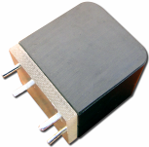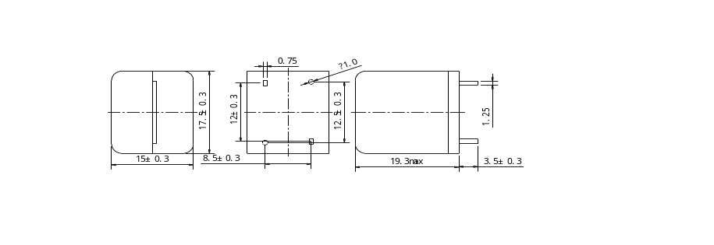
- Pad Layout(mm) ◆ Schematics (Bottom)
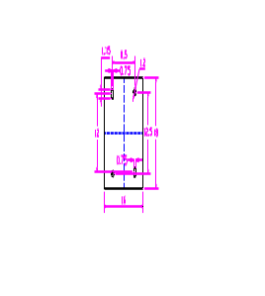
- Characteristic description
TAPE | INDUCTORS  (uH) | Test Frequency | DCR  (mΩ) | Saturation Current(A) | Temperature  Rise Current(A) | Test environment
HPE1718 | 10~33 | 1KHz | 10.7 | 26~7.5 | 8.20 | 20℃
a、Saturation Current: The DC current at which the inductance decreases to 75% of
it's nominal value.
b、Temperature rise current:The DC current at which the temperature rise is
△t＝40℃.(Ta＝20℃)
 | Product type | power inductors
 | Type | HPE2322□□□MAB
- Product Description
  - 24.0×21.0mm Max. (L×W), 23mm Max. height
  - Standard Type, High Power Type, Ultra Power Type are available.
  - Inductance:10uH、22uH、33uH.
  - Saturation Current range: 10.4~37.8A .
  - Temperature rise current range:9.4A.
  - In addition to the standards versions shown here, custom inductors
are also available tomeet your exact requirements.
- Feature& Application
  - Digital Amplifier Inductor/The Flat Wire Use Ferrite Core Type.
  - By using the flat wire, Power inductors can be usrd for large
current with low profile and low resistance.
  - Good shielding, low radiation interference and high fidelity sound effects.
  - Frequency Range: 1MHz
  - RoHS Compliance and Halogen free.
- Dimensions (mm)
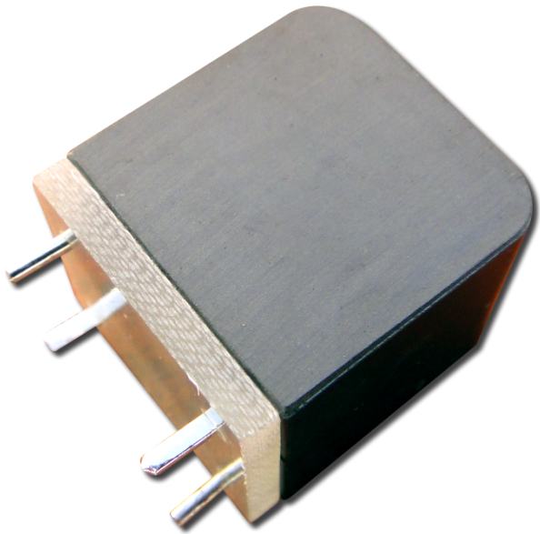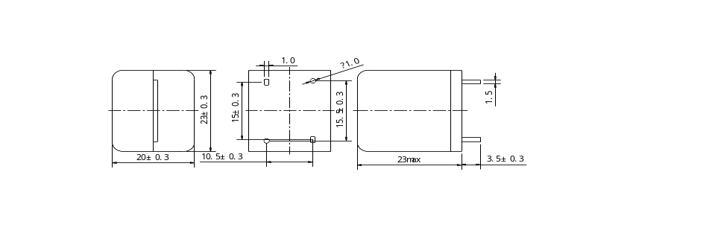
- Pad Layout(mm) ◆ Schematics (Bottom)
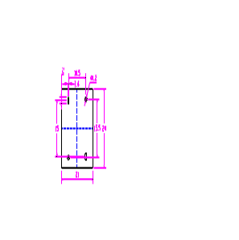
- Characteristic description
TAPE | INDUCTORS  (uH) | Test Frequency | DCR  (mΩ) | Saturation Current(A) | Temperature  Rise Current(A) | Test environment
HPE2322 | 10~33 | 1KHz | 9.60 | 37.8~10.4 | 9.40 | 20℃
a、Saturation Current: The DC current at which the inductance decreases to 75% of
it's nominal value.
b、Temperature rise current:The DC current at which the temperature rise is
△t＝40℃.(Ta＝20℃)
 | Product type | power inductors
 | Type | HPE3132□□□MAB
- Product Description
  - 31.5×19.5mm Max. (L×W), 33mm Max. height
  - Standard Type, High Power Type, Ultra Power Type are available.
  - Inductance:18uH、22uH.
  - Saturation Current range: 30~34A .
  - Temperature rise current range:12.6A.
  - In addition to the standards versions shown here, custom inductors
are also available tomeet your exact requirements.
- Feature& Application
  - Digital Amplifier Inductor/The Flat Wire Use Ferrite Core Type.
  - By using the flat wire, Power inductors can be usrd for large
current with low profile and low resistance.
  - Good shielding, low radiation interference and high fidelity sound effects.
  - Frequency Range: 1MHz
  - RoHS Compliance and Halogen free.
- Dimensions (mm)
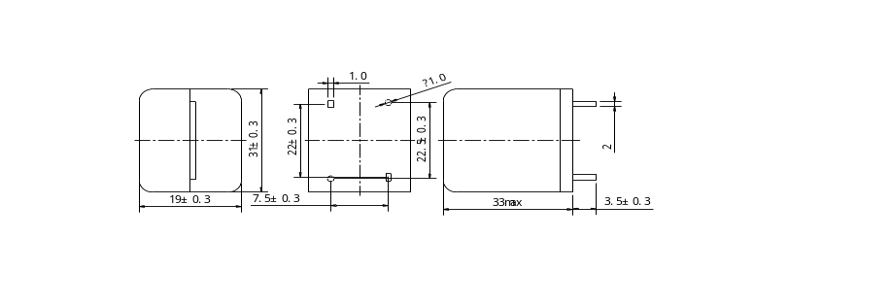
- Pad Layout(mm) ◆ Schematics (Bottom)
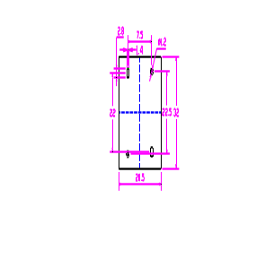
- Characteristic description
TAPE | INDUCTORS  (uH) | Test Frequency | DCR  (mΩ) | Saturation Current(A) | Temperature  Rise Current(A) | Test environment
HPE3132 | 18~22 | 1KHz | 6.3 | 34~30 | 12.6 | 20℃
a、Saturation Current: The DC current at which the inductance decreases to 75% of
it's nominal value.
b、Temperature rise current:The DC current at which the temperature rise is
△t＝40℃.(Ta＝20℃)
 | Product type | power inductors
 | Type | HPQ2622□□□MAB
- Product Description
  - 27.0×12.5mm Max. (L×W), 23mm Max. height
  - Standard Type, High Power Type, Ultra Power Type are available.
  - Inductance:18uH、22uH.
  - Saturation Current range: 30~34A .
  - Temperature rise current range:12.6A.
  - In addition to the standards versions shown here, custom inductors
are also available tomeet your exact requirements.
- Feature& Application
  - Mn-Zn core used, Flat wire used.
  - Ideally used in Power module DC-DC Converter
  - RoHS Compliance and Halogen free.
- Dimensions (mm)
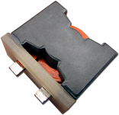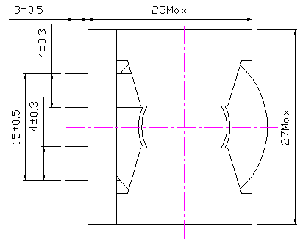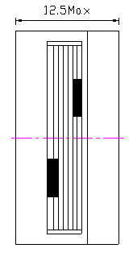
- Pad Layout(mm) ◆ Schematics (Bottom)

- Characteristic description
TAPE | INDUCTORS  (uH) | Test Frequency | DCR  (mΩ) | Saturation Current(A) | Temperature  Rise Current(A) | Test environment
HPQ2622 | 1.0~100 | 100KHz | 2.00~26.8 | 50.0~15 | 45.0~12.0 | 20℃
a、Saturation Current: The DC current at which the inductance decreases to 90% of
it's nominal value.
b、Temperature rise current:The DC current at which the temperature rise is
△t＝40℃.(Ta＝20℃)

 | Product type | power inductors
 | Type | HPQ3226□□□MAB
- Product Description
  - 34.5×34.5mm Max. (L×W), 27.0mm Max. height
  - Standard Type, High Power Type, Ultra Power Type are available.
  - Inductance Range :1.0～50uH.
  - Saturation Current range: 30～120A .
  - Temperature rise current range 23～88A.
  - In addition to the standards versions shown here, custom inductors
are also available tomeet your exact requirements.
- Feature& Application
  - Mn-Zn core used, Flat wire used.
  - Ideally used in Power module DC-DC Converter
  - RoHS Compliance and Halogen free.
- Dimensions (mm)
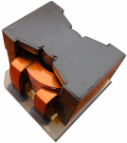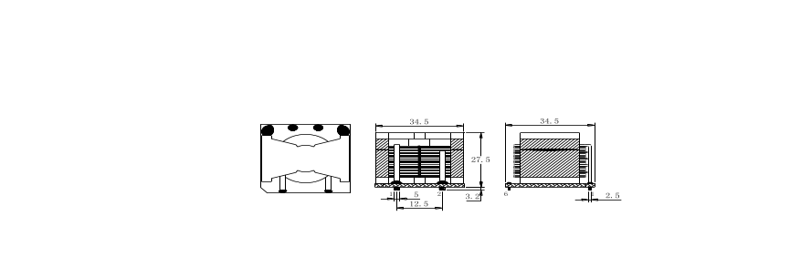
- Pad Layout(mm) ◆ Schematics (Bottom)
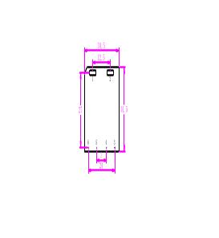
- Characteristic description
TAPE | INDUCTORS  (uH) | Test Frequency | DCR  (mΩ) | Saturation Current(A) | Temperature  Rise Current(A) | Test environment
HPE3132 | 1.0~50 | 100KHz | 0.60~10.8 | 120.0~30 | 88~23 | 20℃
a、Saturation Current: The DC current at which the inductance decreases to 90% of
it's nominal value.
b、Temperature rise current:The DC current at which the temperature rise is
△t＝40℃.(Ta＝20℃)

深圳市品和科技有限公司
深圳龙华三联阁下工业区5栋2楼
陈先生：188 2523 1898
QQ: 898 405 360

